**Simple Calculator**

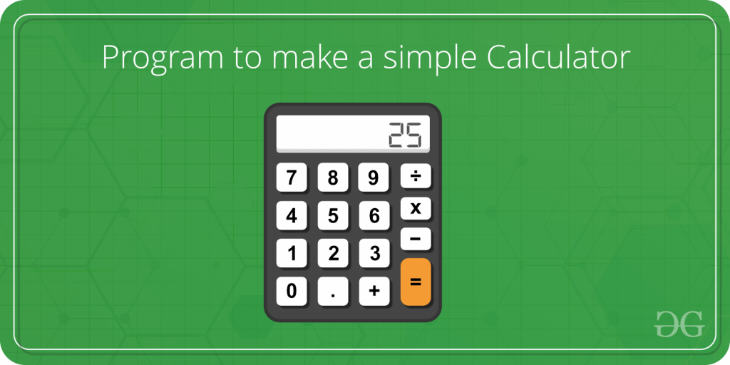

**INPUT**  1 2 3

2 10 5

3 7 3

**OUTPUT** 5 3 15

C++

#include<iostream>

using namespace std;

int main()

{

int op, x, y;

cin >> op >> x >> y;

if(op==1)

{

cout << x + y;

}

else if(op==2)

{

cout << x - y;

}

else if(op==3)

{

cout << x * y;

}

else

{

cout << "Invalid Input";

}

return 0;

}

**INPUT**

2 3 2

**OUTPUT**

1